

**FYS-1320 Methods in Physics**

**Project – Gas analysis by NDIR method.**

**Student Name: Nekhel Das**

**Student Number: 267672**

**Student Name: Qin He**

**Student Number:272486**

**Date: 5.12.2017**

**1.Introduction**

We use the infrared spectroscopy(IR) to study and observe the multi-compound gases (H20, CO, CO2, CH4 and C2H2) here. IR is one method of the optical spectroscopy which also contains ultraviolet (UV) spectroscopy and visible light (VIS) spectroscopy [1]. Here, the absorption bands of H2O, CO, CO2, CH4 and C2H2 are quite different covering from 2000nm to 6000nm. We choose optical method because it is a robust method to have a wider range of testing the compound of the gases. Then we can measure them in one tube together. And it offers a direct, rapid and selective method to measure the gas concentration.

**2. Theoretical background**

**2.1 Beer-Lambert law [3]**

As light is absorbed by a substance its irradiance I [2] is decreased. According to Beer- lambert law, the relationship between the irradiance I0 of the original light entering the substance and the irradiance of the exiting light I depends on the matters concentration c (which we will use to find out what gas it is), the length of the interaction distance L and the probability of the light getting absorbed by the substance also known as the absorption cross section $σ$. The equation describing the relationship is below:

$$\frac{I}{I_{0}}= e^{-σLc}$$

And the linear form of it is:

$$\frac{I}{I_{0}}= 1-σLc$$

We can derive the equation as follows:

$$\frac{I}{I_{0}}=\frac{\int_{λ}{T_{f}T_{g}I_{i}}}{\int_{λ}{T_{f}I_{i}}}$$

where,

I is the measured irradiance, I0 is the comparison irradiance, Tf is the transmission of the filter, Tg is the transmission of the gas, Ii is the irradiance of the light source, ci is the concentration, σi is the absorption cross section, L is the Interaction distance and Δλ is the change of wavelength.

Because of uniform attenuation, right hand equals (Also Ii is equal to the radiant flux derivative of the wavelength, because the Δλs are going to 0, we can approximate the integral with sum):

$$=\frac{\sum_{λ}{T_{f}e^{-cσL}Δλ}}{\sum_{λ}{T_{f}}Δλ}$$

using the Taylor Series expansions of exponential functions in e^(-cσL) and remove higher term

$e^{-cσL}=1+\frac{-cσL}{1!}+… [e^{x}=1+\frac{x}{1!}+…$]

with order as 1, we have the right-hand equation

$$=\frac{\sum_{λ}{T_{f}(}1-cσL)Δλ}{\sum_{λ}{T_{f}}Δλ}$$

$$=1-\frac{\sum_{λ}{T_{f}}cσLΔλ}{\sum_{λ}{T_{f}}Δλ}$$

$$=>(1-\frac{I}{I_{0}})\sum_{λ}{T_{f}Δλ=c_{1}\sum_{λ}{T_{f}σ_{1}LΔλ+c_{2}\sum_{λ}{T_{f}σ_{2}LΔλ+… (1)}}}$$

This is what used to calculate the concentrations because the absorption of the H2O, CO, CO2, CH4 and C2H2 is low enough in out measurements.

**2.2. IR-spectroscopy**

A gas molecule with *N* atoms has 3*N* degrees of freedom. Three of these degrees of freedom are translations in xyz-directions, three rotations around the XYZ-axes and the rest 3*N*-6 are different vibration states. The energies of the rotation and vibration states are quantized and therefore can bind (absorb) or emit energy quanta. The differences between the energy levels of the rotation and vibration states are on the same scale as photons on the IR wavelength. IR-techniques are based mostly on light absorption.

Absorption can happen only when the molecules’ energy level difference is equal to the energy of the photon being absorbed. For this reason, absorption is very selective, and it can be used to recognize specific molecules from each other or measure only a specific molecule’s density in a gas mixture. Molecules in the air also absorb light. Fortunately for life on Earth, it doesn’t happen significantly on the wavelengths of visible light. Instead, the molecules in the atmosphere strongly absorb UV-radiation and the IR spectrum also has a few strong absorption stripes [4]. Figure 1 illustrates the effects of the most common greenhouse gases on the atmosphere’s absorption.

**2.3 NDIR spectroscopy**

The black body radiation is modulated so that thermic background signals can be equalized by using the NDIR equipment [5].

An optical filter is a device where the transmission of light is dependent on its frequency. In its simplest way, the optical filter is an absorptive plastic or glass plate that absorbs only certain frequencies and therefore only a part of the light passes through the filter. Interference or dielectric filters significantly more complex. The filters used in the project are narrow band-pass (Spectrogon) so that a specific band of absorption of the desired molecule can be defined [6].

As the main applied use is to measure the gas and due to NDIRS ’s advantage of accuracy, quick speed, and compact, we may use it to monitor the gas compound. Especially in some manned space to trace gases like carbon dioxide and carbon monoxide to mitigate hazardous accidental events to occur in a crew cabin with its accurate but fast calculation of concentration. Of course, it can then also help to monitor the quality of the air.

**4.Laboratory measurements**



Gas

Reference tube (N2)

Detector

Optical filters

Light source

**Required tools:**

Light source

Pyroelectric light sensor and its reading electronics

Filter wheel

Filters (2710-50 nm, 3060-60 nm, 3220-60 nm, 3977-65 nm, 4270-70 nm, 4740-140 nm, 5756-80 nm)

Evaboard software

Sample gas tube

Comparison gas tube

**Preparing the equipment**

1) Plug in the light sensor to a wall socket and turn on the computer

2) After the computer has turned on plug the USB-cable from the light sensor to the computer

3) Open the Evaboard program from the desktop

4) After the program has opened press the Board searches OFF button => a green “Board found” light should turn on next to the button. If the light doesn’t turn on, wait a while and press the button again.

5) Set the Emitter settings for the measurement: Frequency, Duty cycle 50 and pulsation on

6) Click the Software filter Lowpass to the on position and change the threshold frequency to 1.

7) Change the Measurement mode to the peak-to-peak position.

8) Set the comparison gas tube (N2) onto the holders between the light source and the light sensor Measuring.

Start

Meas

9) Start the measuring by pressing the button => The Channel1 graph shows a white wave and the Measurement value history graph starts to draw a graph of the peak-to-peak values of the measured light pulse intensity.

10) Turn the filter wheel to select the chosen filter.

11) Turn on averaging with the Averaging button and set the averaging time to the desired one.

off

12) Change the y-scale of the Measurement value history graph to be more accurate around the white result line by clicking the y-axis with the right mouse button and turning off Auto scale. After this, you can type in new upper and lower bounds for the graph by double-clicking them. Measure the averaged peak-to-peak value and write it down in the measurement transcript with at least one decimal precision. Alternatively, you can use continuous saving and write down the timings of the measurements in the transcript.

13) Choose the filter to be measured from the filter wheel and measure the averaged peak-to-peak value and write it down

14) Turn the filter wheel to the next filter and repeat sections 12-15 until all filters have been measured

15) Choose the filter from the filter wheel and write down the peak-to-peak value of the intensity. Change the gas tube to the sample gas tube (custom mixture) so that the tube would be as close as possible to the position of the comparison tube. Adjust the tube by turning the filters peak-to-peak value to the same level it was with the comparison tube just before the swap. This might not work perfectly due to the variation of intensity of the light source. Write down the level of the transcript.

16) Repeat sections 12-15 with the sample gas tube.

Stop

Meas

17) Stop the measurement by pressing the button

18) Close the program and shut down the computer and unplug the USB-cable from the computer and the light sensor from the power socket.

**5.pre-calculation and selection of filter**

Now, we will see how to choose the filters.

First, we need to know the basic calculation command help to calculate the left-hand side of the equation (*):.

Wavelength axis is not equally spaced, so add the first of dlambda once more.

dlambda=diff(lambda);

dlambda=abs([dlambda(1);dlambda]);

With the simulation of H2O as example:

cons_H2O=1000*1e-6;

trans_H2O=exp(-cons_H2O*p/(k*T)*H2O/1e4*L);

After we have the data of filter1,

I0=sum(filter1*1e-2.dlambda);

I=sum(filter1*1e-2.*trans_H2O.*dlambda);

We have :

A=1-I./I0

Then we model the absorption caused by five gases (H2O, CO2, CO, CH4, C2H2) in a 20-cm-long tube in a wavelength-transmission graph, when their concentrations are 1000 ppm.

We then utilize the beer and Lambert law to calculate the transmission (Note absorption cross-section needs to be changed from cm^2 to m^2 => multiply 1e4)

Then we plot the transmission spectrum and in the same graph, calculate what the total absorption is in each filters’ section.

We thus have:

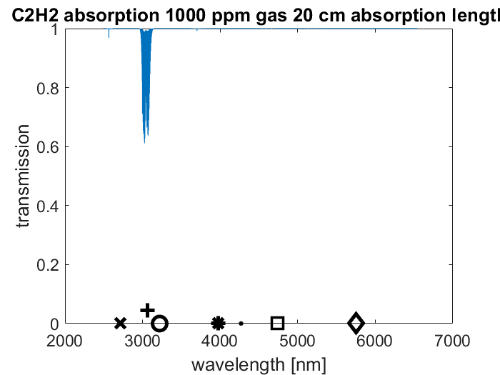

Figure 5-1: Transmission vs wavelength by using filter 3060-60nm for the C2H2

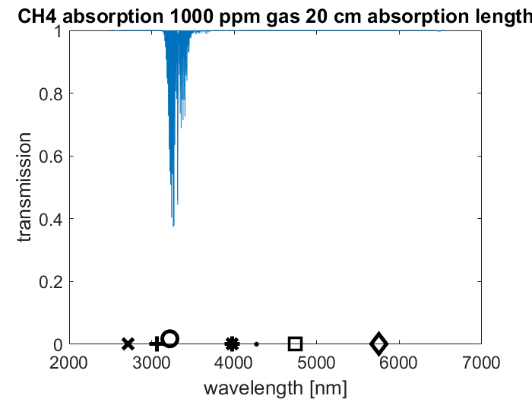

Figure 5-2: Transmission vs wavelength by using filter 3220-60nm for the CH4.

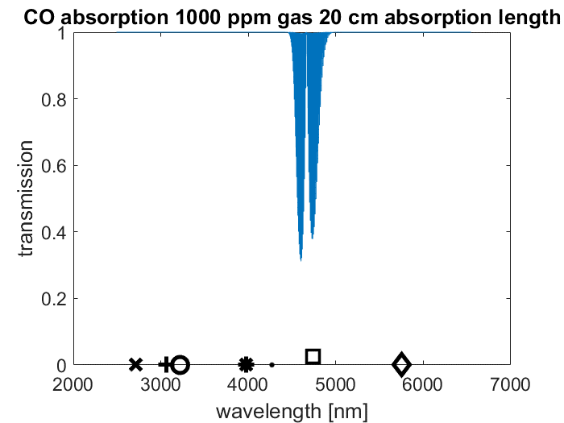

Figure 5-3: Transmission vs wavelength by using filter 4740-140nm can be used for the CO.

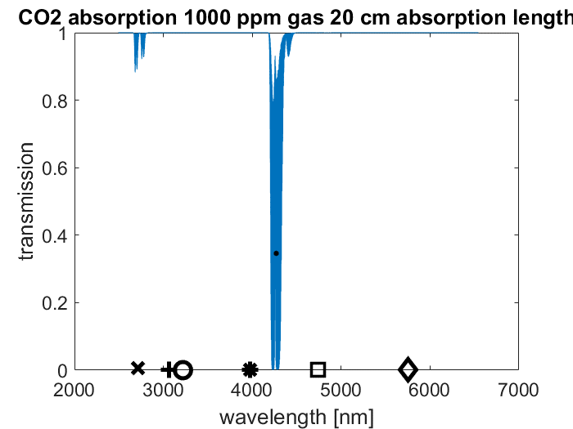

Figure 5-4: Transmission vs wavelength by using either filter 2710-60nm or 4270-70nm for the CO2.

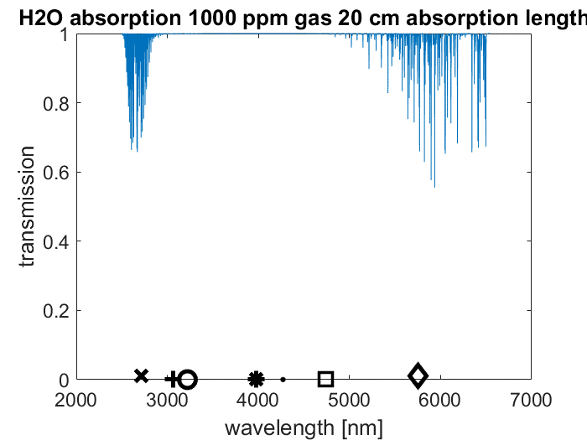

Figure 5-5: Transmission vs wavelength by using either filter 2710-60nm or 5756-80nm can be used for the H2O.

Note that the position of the gas tubes used in the project affects the results. For this reason, it is important that all the tubes are positioned in the same way. The tubes can be adjusted to the same position by comparing the amount of light that passes through them with a certain filter. We then choose one filter to be used based on confirming the position of the tube as well as for the normalization of the intensity of the light source (which means to get the value of I0): The 3977-65nm filter. Because any of the gas will not be absorbed by that band.

And because the test tube only contains five gases, it is enough that measurements done in only the sections of five filters are used in the calculations. According to the figure 4 and 5, both the H20 and CO2 will be absorbed on the 60nm band. We thus leave this one out.

Finally, we have the e 3977-65nm filter for getting I0 and the proper position. 5756-80nm filter for the H2O, filter 4270-70nm for the CO2, filter 4740-140nm can be used for the CO, filter 3220-60nm for the CH4 and filter 3060-60nm for the C2H2.

**6.Measurement results and observations**

After setting up the filters and the tube, we collected three sets of the data of different gas samples: the test mixed gas (given by lab assistant), indoor air (collected by ourselves), outdoor air (collected by ourselves). Then we use two different ways to calculate the concentrations. First, use the matrix inverse: C=A'.\Y; The second is to calculate the different concentration separately.

For mixed sample air, we can identify 5 different gases which are H2O, CO2, C2H2, CH4, and CO. Their concentration(ppm) calculated by two ways are shown in the following table:

|  |  |  |  |  |  |
| --- | --- | --- | --- | --- | --- |
| Concentration(ppm) calculation method | H2O | CO2 | C2H2 | CH4 | CO |
| Matrix inverse | 83448 | 1335 | 29861164 | 19768102 | 2487 |
| Separately with ln | 533770 | 88007 | 77603 | 762630 | 9755 |

Table 6-1 Concentration (ppm) of H2O, CO2, C2H2, CH4 and CO calculated by matrix inverse and ln separately.

Surprisingly, the concentration of H2O, CO2 and CO calculated by matrix inverse are all smaller than ln calculation separately while the C2H2 and CH4 are of opposite results.

Results can be also shown in the bar chart (Because the concentrations of C2H2 and CH4 are significantly larger than others, we plot them in two bar charts to compare) as follows:

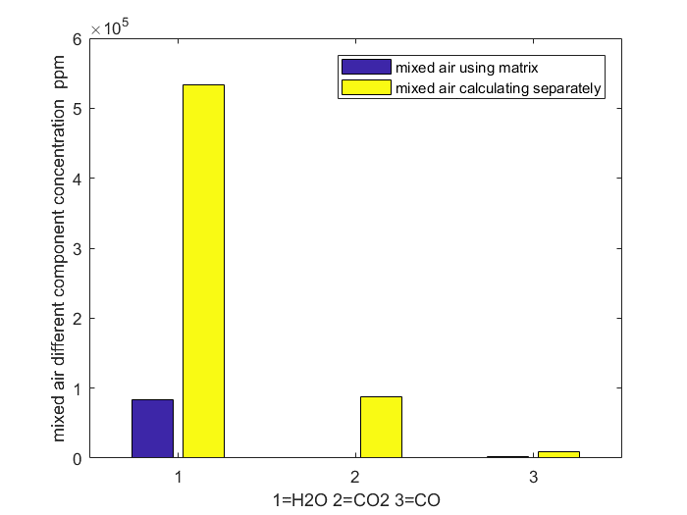

Figure 6-1 concentrations of H20, CO2, and CO separately using matrix inverse(blue) and ln calculation separately.

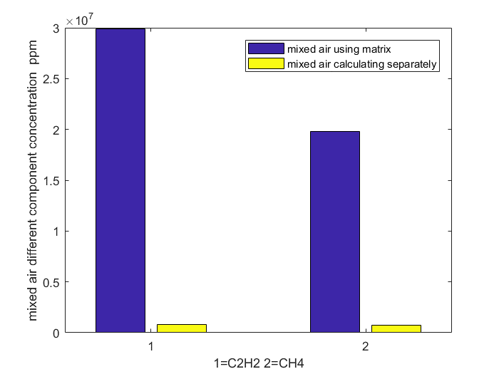

Figure 6-2 concentrations of C2H2 and CH4 separately using matrix inverse(blue) and ln calculation(yellow) separately.

In the next part, we use the same two calculation way trying to figure out the different components of lab air and outdoor air. We bring up the assumption that only CO2, H2O, and C2H2 can be found in both indoor and outdoor air. Apparently, CO should be excluded because it’s poisonous. CH4 is also not commonly seen in daily activity places and we don’t have a factory, swamp etc. nearby. The result of the mixed indoor air and the outdoor air can be shown in the same two ways:

|  |  |  |  |  |  |  |
| --- | --- | --- | --- | --- | --- | --- |
| Concentration(ppm)  calculation method | H2O (indoor) | CO2 (indoor) | C2H2(indoor) | H2O(outdoor) | CO2(outdoor) | C2H2(outdoor) |
| Matrix inverse | 1529 | 253 | 2941568 | 83448 | 1335 | 29861164 |
| Separately with ln | 1423 | 2522 | 11585 | 4848 | 2458 | 12842 |

Table 6-2 Concentration(ppm) of H2O, CO2, C2H2 Both indoor and outdoor calculated by matrix inverse and ln separately.

Again, the two calculation gives different concentration. The concentration of H2O calculated in different ways is relatively closer, especially in the indoor case. However, the concentration of CO2 calculated by matrix inverse is about 10 times smaller than by ln individually and the difference is about 50% for the outdoor CO2 result. The concentration of C2H2 calculated by matrix inverse is even 300 times larger than the ln both in the outdoor and indoor air.

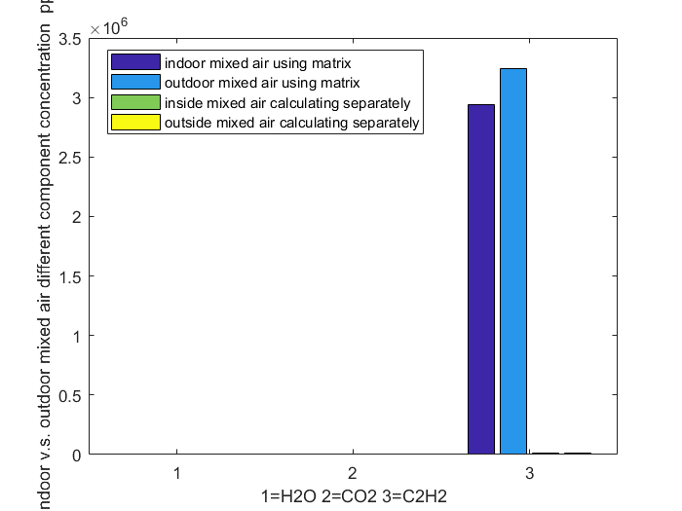

Figure 6-3 concentrations of H20, CO2 and C2H2 calculated separately using matrix inverse for indoor (dark blue), outdoor (light blue) and ln calculation for indoor(green)and outdoor(yellow)separately.

But the concentration of C2H2 is too high, so we observe the results of H2O and CO2 together in the following bar chart:

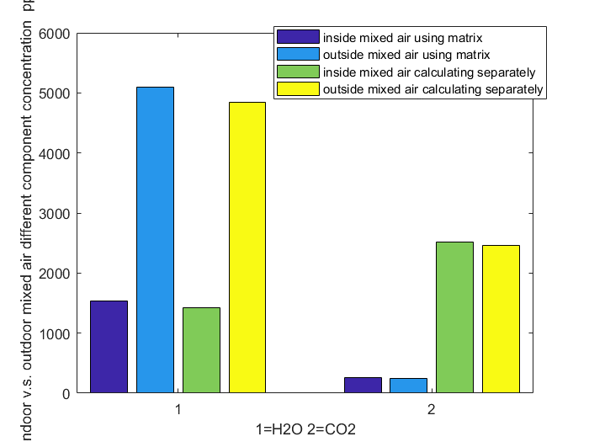

Figure 6-4 concentrations of H20 and calculated separately using matrix inverse for indoor (dark blue), outdoor (light blue) and ln calculation for indoor(green)and outdoor(yellow)separately.

**7.Results analysis**

1. **Error analysis**

In general, concentration calculated by matrix inverse and ln are quite different which is not what we expect, because theoretically, the absorption of the H2O, CO, CO2, CH4, and C2H2 is low enough in out measurements which guarantees the correctness of uniform way of the Lambert law. Thus, we think the main error is brought during our measurement. Our careless of moving the tube from the initial position, for example, can change the I0 for our gas. Additionally, we may also introduce error when injecting the gas sample into the tube. Position of the tube also can affect the result because we should keep same position in setup for all the tube of different mixer tube for more accurate value. Air from our breath may can affect or during changing the cover of that setup. If there are any fingerprint or dust in lens it also can affect the result.

1. **Conclusion**

The components of the sample gas mixture are C2H2 CH4 H2O CO CO2 in concentration decreasing order using matrix inverse while by calculating separately with ln, we get the order is CH4 H2O C2H2 CO2 CO. Similarly, for the indoor mixture, according to the matrix inverse, the major part is the C2H2, second is H2O and CO2 last while when using the ln to calculate separately, we find the C2H2 to be the largest part, then the CO2 and finally the H2O. For the outdoor, the results are the same, C2H2 is the largest, then the H2O and the CO2 the least.

Using the NDIR, we can calculate the concentrations of the component of a gas mixture as long as we know the proper bandwidth of the filter according to the component’s cross absorption. And it’s a convenient way which does not require us to separate the gas before the measurement. We only need to change different filters to filter the mixture. This prevents us breaking the construct of the origin gas. However, one important thing needs to note is the fixed position of the tube which determines the I0. Our result is not so satisfying, having significantly different results of the concentration of different components may be caused by this mistake.

**8.References**

[1] Wikipedia- Infrared spectroscopy [internet] updated at 02.11.2017 [reference date: 30.11.2017]. Available: https://en.wikipedia.org/wiki/Infrared_spectroscopy.

[2] Irradiance, [internet] updated at 31.10.2017 [referenced 10.5.2014], available: <http://en.wikipedia.org/wiki/Irradiance>

[3] Beer-Lambert law, [internet] updated at 19.11.2017 [referenced 10.5.2014], available:

<http://en.wikipedia.org/wiki/Beer%E2%80%93Lambert_law>

[4] Hollas, J.M, Modern Spectroscopy, 4th edition, 2004, John Wiley & Sons Ltd, available:

<http://lib.myilibrary.com/Open.aspx?id=26961&src=2>

[5] Schroeder, D.V., An Introduction to Thermal Physics, 2000, Addison Wesley Longman, s. 288-307

[6] Infrared gas analyser, [internet] [referenced: 13.5.2014], available:

http://en.wikipedia.org/wiki/Infrared_gas_analyzer

**9. appendix**

Now, we will see how to calculate the concentration from the measured I and I0 with the MATLAB.

First, we need to know the basic calculation command help to calculate the left-hand side of the equation (*):

Wavelength axis is not equally spaced, so add the first of dlambda once more:

dlambda=diff(lambda);

dlambda=abs([dlambda(1);dlambda]);

With the simulation of H2O as example:

cons_H2O=1000*1e-6;

trans_H2O=exp(-cons_H2O*p/(k*T)*H2O/1e4*L);

After we have the data of filter1,

I0=sum(filter1*1e-2.dlambda);

I=sum(filter1*1e-2.*trans_H2O.*dlambda);

We have :

A=1-I./I0

Then we model the absorption caused by five gases (H2O, CO2, CO, CH4, C2H2) in a 20-cm-long tube in a wavelength-transmission graph when their concentrations are 1000 ppm.

With their concentration being 1000ppm,

cons_C2H2= 1000*1e-6; % ppm => 1e-6

cons_CH4= 1000*1e-6; % ppm => 1e-6

cons_CO= 1000*1e-6; % ppm => 1e-6

cons_CO2= 1000*1e-6; % ppm => 1e-6

cons_H2O= 1000*1e-6; % ppm => 1e-6

We then utilize the beer and lambert law to calculate the transmission (Note absorption cross-section needs to be changed from cm^2 to m^2 => multiply 1e4)

trans_H2O=exp(-cons_H2O*p/(k*T)*H2O/1e4*L);

trans_C2H2=exp(-cons_C2H2*p/(k*T)*C2H2/1e4*L)

trans_CH4=exp(-cons_CH4*p/(k*T)*CH4/1e4*L);

trans_CO=exp(-cons_CO*p/(k*T)*CO/1e4*L);

trans_CO2=exp(-cons_CO2*p/(k*T)*CO2/1e4*L);

Then we plot the transmission spectrum

figure

plot(lambda,trans_H2O)

set(gca,'fontsize',14)

xlabel('wavelength [nm]')

ylabel('transmission')

title('H2O absorption 1000 ppm gas 20 cm absorption length')

figure(2)

plot(lambda,trans_C2H2)

set(gca,'fontsize',14)

xlabel('wavelength [nm]')

ylabel('transmission')

title('C2H2 absorption 1000 ppm gas 20 cm absorption length')

figure(3)

plot(lambda,trans_CH4)

set(gca,'fontsize',14)

xlabel('wavelength [nm]')

ylabel('transmission')

title('CH4 absorption 1000 ppm gas 20 cm absorption length')

figure(4)

plot(lambda,trans_CO)

set(gca,'fontsize',14)

xlabel('wavelength [nm]')

ylabel('transmission')

title('CO absorption 1000 ppm gas 20 cm absorption length')

figure(5)

plot(lambda,trans_CO2)

set(gca,'fontsize',14)

xlabel('wavelength [nm]')

ylabel('transmission')

title('CO2 absorption 1000 ppm gas 20 cm absorption length')

In the same graph, calculate what the total absorption is in each filters’ section.

Take the H2O as example:

Note: transmission vectors are in percentage so need to multiply by 1e-2

I01(1,:)=sum(NB2710*1e-2.*dlambda);

I1(1,:)=sum(NB2710*1e-2.*trans_H2O.*dlambda);

I02(1,:)=sum(NB3060*1e-2.*dlambda);

I2(1,:)=sum(NB3060*1e-2.*trans_H2O.*dlambda);

I03(1,:)=sum(NB3220*1e-2.*dlambda);

I3(1,:)=sum(NB3220*1e-2.*trans_H2O.*dlambda);

I04(1,:)=sum(NB3977*1e-2.*dlambda);

I4(1,:)=sum(NB3977*1e-2.*trans_H2O.*dlambda);

I05(1,:)=sum(NB4270*1e-2.*dlambda);

I5(1,:)=sum(NB4270*1e-2.*trans_H2O.*dlambda);

I06(1,:)=sum(NB4740*1e-2.*dlambda);

I6(1,:)=sum(NB4740*1e-2.*trans_H2O.*dlambda);

I07(1,:)=sum(NB5756*1e-2.*dlambda);

I7(1,:)=sum(NB5756*1e-2.*trans_H2O.*dlambda);

Calculate transmitted intensity over original intensity and absoption:

TR1(1,:)=I1(1,:)./I01(1,:);

A1(1,:)=1-TR1(1,:);

TR2(1,:)=I2(1,:)./I02(1,:);

A2(1,:)=1-TR2(1,:);

TR3(1,:)=I3(1,:)./I03(1,:);

A3(1,:)=1-TR3(1,:);

TR4(1,:)=I4(1,:)./I04(1,:);

A4(1,:)=1-TR4(1,:);

TR5(1,:)=I5(1,:)./I05(1,:);

A5(1,:)=1-TR5(1,:);

TR6(1,:)=I6(1,:)./I06(1,:);

A6(1,:)=1-TR6(1,:);

TR7(1,:)=I7(1,:)./I07(1,:);

A7(1,:)=1-TR7(1,:);

Finally, plot average absorption at the bandpass into the same plot with the spectrum

hold on

figure(1)

plot(2710 ,A1(1,:),'kx','Markersize',12,'linewidth',3)

hold on

figure(1)

plot(3060 ,A2(1,:),'k+','Markersize',12,'linewidth',3)

hold on

figure(1)

plot(3220 ,A3(1,:),'ko','Markersize',12,'linewidth',3)

hold on

figure(1)

plot(3977 ,A4(1,:),'k*','Markersize',12,'linewidth',3)

hold on

figure(1)

plot(4270 ,A5(1,:),'k.','Markersize',12,'linewidth',3)

hold on

figure(1)

plot(4740 ,A6(1,:),'ks','Markersize',12,'linewidth',3)

hold on

figure(1);

plot(5756 ,A7(1,:),'kd','Markersize',12,'linewidth',3)

%% Calculate the concentration of the gas(indoor vs. outdoor)

clear

close all;

% Load absorption cross-sections of H2O and CO2, and the filter

% transmission curves

load('ino.mat', 'iH2O','iC2H2','iCH4','iCO2','oH2O','oC2H2','oCH4','oCO2')

load('N2.mat', 'N2_5756','N2_3060','N2_3220','N2_4270')

load('gases_carbon.mat','C2H2','CH4','CO','CO2','H2O','lambda')

load('filter','NB5756','NB3060','NB3220','NB3977','NB4270','NB4740')

% Wavelength axis is not equally spaced, so that has to be taken in to

% account

dlambda=diff(lambda);

dlambda=[dlambda(1);dlambda];

% Environmental parameters

p=1.013e5; % Pa, Gas pressure

k=1.38e-23; % J/K, Boltzmann constant

T=298; % K, Gas temperature

L=0.2; % m, Length of the gas cell

% Concentration solved with multivariable matrix method.

% Matrix is defined

alphain_H2O=sum(H2O.*NB5756*1e-2.*dlambda);

alphain_CO2=sum(CO2.*NB4270*1e-2.*dlambda);

alphain_C2H2=sum(C2H2.*NB3220*1e-2.*dlambda);

%alphain_CH4=sum(CH4.*NB3060*1e-2.*dlambda);

alphaout_H2O=sum(H2O.*NB5756*1e-2.*dlambda);

alphaout_CO2=sum(CO2.*NB4270*1e-2.*dlambda);

alphaout_C2H2=sum(C2H2.*NB3220*1e-2.*dlambda);

%alphaout_CH4=sum(CH4.*NB3060*1e-2.*dlambda);

A1=[alphain_H2O alphain_CO2 alphain_C2H2 ].*p./(k*T)./1e4.*L;

A2=[alphaout_H2O alphaout_CO2 alphaout_C2H2 ].*p./(k*T)./1e4.*L;

% System of equations has an result vector with measured intensity ratios

I0=[mean(N2_5756) mean(N2_4270) mean(N2_3220)]*10^(-3); %[I_NB2710 I_NB5756] Vectors are created with measured values

I1=[mean(iH2O) mean(iCO2) mean(iC2H2) ]*10^(-3);

I2=[mean(oH2O) mean(oCO2) mean(oC2H2)]*10^(-3);

% Create Y-vector of the matrix equation AC=Y

y11(1)=(1-I1(1)/I0(1))*sum(NB5756*1e-2.*dlambda);

y12(1)=(1-I1(2)/I0(2))*sum(NB4270*1e-2.*dlambda);

y13(1)=(1-I1(3)/I0(3))*sum(NB3220*1e-2.*dlambda);

% y14(1)=(1-I1(4)/I0(4))*sum(NB3060*1e-2.*dlambda);

y21(1)=(1-I2(1)/I0(1))*sum(NB5756*1e-2.*dlambda);

y22(1)=(1-I2(2)/I0(2))*sum(NB4270*1e-2.*dlambda);

y23(1)=(1-I2(3)/I0(3))*sum(NB3220*1e-2.*dlambda);

% y24(1)=(1-I2(4)/I0(4))*sum(NB3060*1e-2.*dlambda);

Y1=[y11;y12;y13];

Y2=[y21;y22;y23];

% Concentrations are calculated by matrix inverse

C1=A1'.\Y1;

C2=A2'.\Y2;

C_1(1)=-log(I1(1)/I0(1))/mean(H2O)*1e-16/L;

C_1(2)=-log(I1(2)/I0(2))/mean(CO2)*1e-16/L;

C_1(3)=-log(I1(3)/I0(3))/mean(C2H2)*1e-16/L;

%C_1(4)=-log(I1(4)/I0(4))/mean(CH4)*1e-16/L;

C_2(1)=-log(I2(1)/I0(1))/mean(H2O)*1e-16/L;

C_2(2)=-log(I2(2)/I0(2))/mean(CO2)*1e-16/L;

C_2(3)=-log(I2(3)/I0(3))/mean(C2H2)*1e-16/L;

%C_2(4)=-log(I2(4)/I0(4))/mean(CH4)*1e-16/L;

disp('For indoor mixed air ')

disp(['Gas concentrations: H2O: ' num2str(C1(1)*1e6) ' ppm ja CO2: ' num2str(C1(2)*1e6) ' ppm ja C2H2: ' num2str(C1(3)*1e6) ])

disp('For outdoor mixed air ')

disp(['Gas concentrations: H2O: ' num2str(C2(1)*1e6) ' ppm ja CO2: ' num2str(C2(2)*1e6) ' ppm ja C2H2: ' num2str(C2(3)*1e6) ])

figure;

%plot(1:3,C1(1:3),'ro',1:3,C2(1:3),'bx',1:3,C_1(1:3),'go',1:3,C_2(1:3),'cx');

bar([C1*1e6,C2*1e6,C_1(1:3)',C_2(1:3)']);

legend('indoor mixed air using matrix','outdoor mixed air using matrix','inside mixed air calculating separately','outside mixed air calculating separately')

xlabel('1=H2O 2=CO2 3=C2H2');

ylabel('indoor v.s. outdoor mixed air different component concentration ppm')

figure;

bar([C1(1:2)*1e6,C2(1:2)*1e6,C_1(1:2)',C_2(1:2)']);

legend('inside mixed air using matrix','outside mixed air using matrix','inside mixed air calculating separately','outside mixed air calculating separately')

xlabel('1=H2O 2=CO2');

ylabel('indoor v.s. outdoor mixed air different component concentration ppm')

%% Mixed air

% clear

% close all;

% Load absorption cross-sections of H2O and CO2, and the filter

% transmission curves

load('mix.mat')

load('N2.mat', 'N2_5756','N2_3060','N2_3220','N2_4270','N2_4740')

load('gases_carbon.mat','C2H2','CH4','CO','CO2','H2O','lambda')

load('filter','NB5756','NB3060','NB3220','NB3977','NB4270','NB4740')

% Wavelength axis is not equally spaced, so that has to be taken in to

% account

dlambda=diff(lambda);

dlambda=[dlambda(1);dlambda];

% Environmental parameters

p=1.013e5; % Pa, Gas pressure

k=1.38e-23; % J/K, Boltzmann constant

T=298; % K, Gas temperature

L=0.2; % m, Length of the gas cell

% Concentration solved with multivariable matrix method.

% Matrix is defined

alpha_H2O=sum(H2O.*NB5756*1e-2.*dlambda);

alpha_CO2=sum(CO2.*NB4270*1e-2.*dlambda);

alpha_C2H2=sum(C2H2.*NB3220*1e-2.*dlambda);

alpha_CH4=sum(CH4.*NB3060*1e-2.*dlambda);

alpha_CO=sum(CO.*NB4740*1e-2.*dlambda);

A=[alpha_H2O alpha_CO2 alpha_C2H2 alpha_CH4 alpha_CO].*p./(k*T)./1e4.*L;

% System of equations has an result vector with measured intensity ratios

I0=[mean(N2_5756) mean(N2_4270) mean(N2_3220) mean(N2_3060) mean(N2_4740)]*10^(-3); %[I_NB2710 I_NB5756] Vectors are created with measured values

I=[mean(MH2O5756) mean(MCO24270) mean(MC2H23220) mean(MCH43060) mean(MCO4740)]*10^(-3);

% Create Y-vector of the matrix equation AC=Y

y1(1)=(1-I(1)/I0(1))*sum(NB5756*1e-2.*dlambda);

y2(1)=(1-I(2)/I0(2))*sum(NB4270*1e-2.*dlambda);

y3(1)=(1-I(3)/I0(3))*sum(NB3220*1e-2.*dlambda);

y4(1)=(1-I(4)/I0(4))*sum(NB3060*1e-2.*dlambda);

y5(1)=(1-I(5)/I0(5))*sum(NB4740*1e-2.*dlambda);

Y=[y1;y2;y3;y4;y5];

% Concentrations are calculated by matrix inverse

C=A'.\Y;

disp('For mixed sample air ')

disp(['Gas concentrations: H2O: ' num2str(C(1)*1e6) ' ppm ja CO2: ' num2str(C(2)*1e6) ' ppm ja C2H2: ' num2str(C(3)*1e6) ' ppm ja CH4: ' num2str(C(4)*1e6) ' ppm ja CO: ' num2str(C(5)*1e6)])

C_(1)=-log(I(1)/I0(1))/mean(H2O)*1e-16/L;

C_(2)=-log(I(2)/I0(2))/mean(CO2)*1e-16/L;

C_(3)=-log(I(3)/I0(3))/mean(C2H2)*1e-16/L;

C_(4)=-log(I(4)/I0(4))/mean(CH4)*1e-16/L;

C_(5)=-log(I(5)/I0(5))/mean(CO)*1e-16/L;

figure;

bar([C*1e6,C_']);

legend('mixed air using matrix','mixed air calculating separately')

xlabel('1=H2O 2=CO2 3=C2H2 4=CH4 5=CO');

ylabel('mixed air different component concentration ppm')

figure;

bar([[C(1);C(2);C(5)]*1e6,[C_(1);C_(2);C_(5)]]);

legend('mixed air using matrix','mixed air calculating separately')

xlabel('1=H2O 2=CO2 3=CO');

ylabel('mixed air different component concentration ppm')

figure;

bar([[C(3);C(4)]*1e6,[C_(3);C_(4)]]);

legend('mixed air using matrix','mixed air calculating separately')

xlabel('1=C2H2 2=CH4');

ylabel('mixed air different component concentration ppm')